Bootstrap 5 Tables

## **Basic Table**

A basic Bootstrap 5 table has a light padding and horizontal dividers.

The .table class adds basic styling to a table:

Example

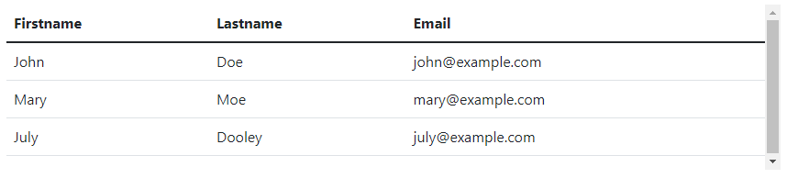

## **Striped Rows**

The .table-striped class adds zebra-stripes to a table:

Example

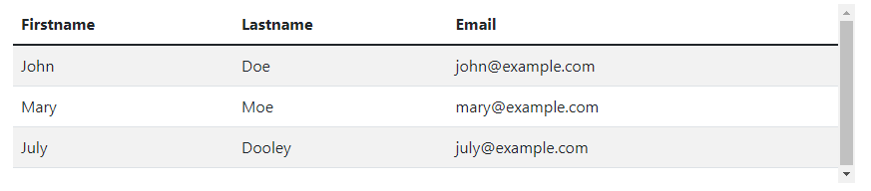

## **Bordered Table**

The .table-bordered class adds borders on all sides of the table and cells:

### **Example**

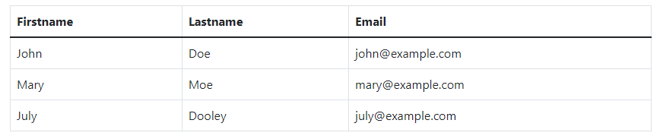

For more information [clickhere](https://www.w3schools.com/bootstrap5/bootstrap_tables.php)

References

https://www.w3schools.com/bootstrap5/bootstrap_tables.php